What is Programming Language?
Provide the computer a set of instructions that are written in a language that the computer can understand. The instructions could be of various types. For example:
- Adding 2 numbers.
- Printing Text on screen.
Just like we humans can understand a few languages (English, Spanish, Mandarin, French, etc.), so is the case with computers. Computers understand instructions that are written in a specific syntactical form called a programming language. Various Programming Languages are C, C++, Python, Java, Ruby, etc.

What can you do with Python?
- Web Development – Make websites using Django, Pyramid, Flask etc. Some popular websites made in Python are Instagram, Spotify, Nasa Official website and many more.
- Building Games - Python supports developing games. Its Pygame library is highly useful.
- Web Scraping – Fetch Real Time data from websites.
- Data Science, Machine Learning and Artificial Intelligence – Some popular libraries are Numpy, Pandas, Matplotlib, Tensorflow, PyTorch, etc.
- Robotics - Python can be used to code to function as the brain of a robot.
- Desktop GUI – Make desktop applications using PyQT.

Who Developed Python?
Python was developed by Guido van Rossum and first version of python was first released in 1991 which we can call Python1. On 16th Oct 2000, the next version i.e Python2 was released. Seeing some drawbacks of Python2, Python3 was released on 3rd Dec, 2008.

What is Python?
Python is a general purpose, dynamic, high level and interpreted programming language. It supports Object Oriented programming approach to develop applications. It is simple and easy to learn and provides lots of high-level data structures.
Python is easy to learn yet powerful and versatile scripting language which makes it attractive for Application Development.
Python's syntax and dynamic typing with its interpreted nature, makes it an ideal language for scripting and rapid application development.
Python supports multiple programming pattern, including object oriented, imperative and functional or procedural programming styles.
Python is not intended to work on special area such as web programming. That is why it is known as multipurpose because it can be used with web, enterprise, 3D CAD etc.
We don't need to use data types to declare variable because it is dynamically typed so we can write a=10 to assign an integer value in an integer variable.
Python makes the development and debugging fast because there is no compilation step included in python development and edit-test-debug cycle is very fast.

Python Features
Python provides lots of features that are listed below.
1) Easy to Learn and Use
Python is easy to learn and use. It is developer-friendly and high level programming language.
2) Expressive Language
Python language is more expressive means that it is more understandable and readable.
3) Interpreted Language
Python is an interpreted language i.e. interpreter executes the code line by line at a time. This makes debugging easy and thus suitable for beginners.
4) Cross-platform Language
Python can run equally on different platforms such as Windows, Linux, Unix and Macintosh etc. So, we can say that Python is a portable language.

5) Free and Open Source
Python language is freely available at offical web address.The source-code is also available. Therefore it is open source.
6) Object-Oriented Language
Python supports object oriented language and concepts of classes and objects come into existence.
7) Extensible
It implies that other languages such as C/C++ can be used to compile the code and thus it can be used further in our python code.
8) Large Standard Library
Python has a large and broad library and prvides rich set of module and functions for rapid application development.
9) GUI Programming Support
Graphical user interfaces can be developed using Python.
10) Integrated
It can be easily integrated with languages like C, C++, JAVA etc.

How to download Python?
Python has it official Website i.e https://www.python.org/ . We would be using Python3 for our entire course.
Head Over to https://www.python.org/downloads/ to check out various Python Versions. In Looking for Specific Release section, go and download Python Version 3.8.6.
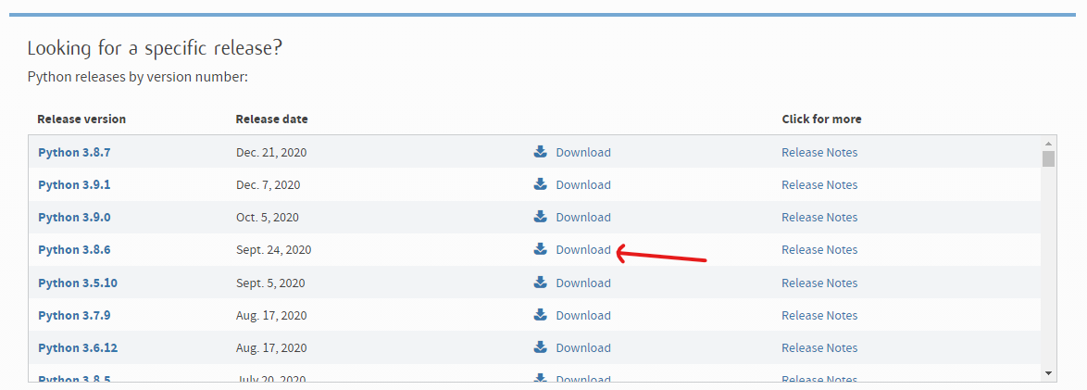
Go to the Files Section, and download Windows x86-64 executable installer for 64 bit or Windows x86 executable installer for 32 bit. We will be downloading Windows x86 executable installer.
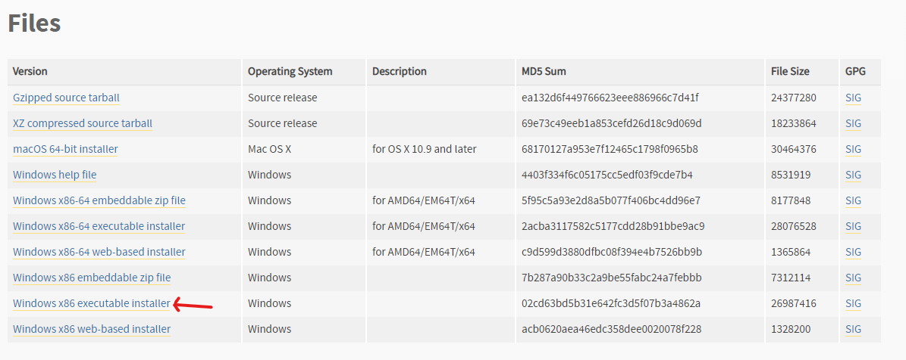
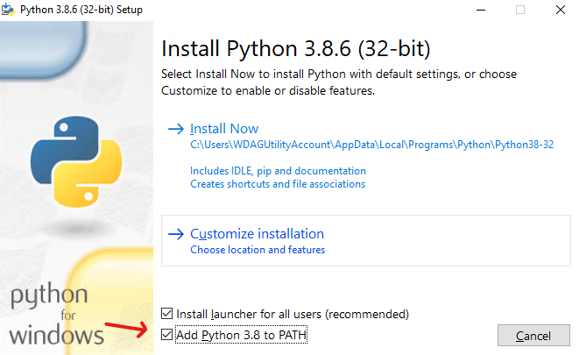
Run the downloaded file and follow the instructions below. Make sure Add Python 3.8 to PATH is checked and click install now.

After installation is successful, press CTRL+R and type cmd.
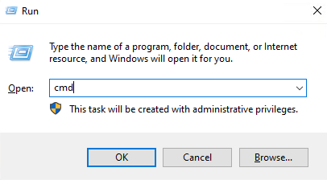

Type python –v to check the version of Python Installed.
